Elmdale School Parent Advisory Council
Thurs. Feb. 18/16

In attendance: Colin, Marge, Laurena, Melissa, Janet, Tess, Joshelyn, Jason, Sacha, Anita.
Regrets: Anne, Jolene.
Welcome. Minutes from Jan. 14/16 approved.
Elmdale Report:
- February is I Love to Read Month! To celebrate, a book fair will take place from Feb. 22-25 in the library.
- A Family Celebration of Learning will take place on Feb. 25 from 2:15 – 3:15 at the school.
- Feb. 26 – PD Day – No classes
- Mar. 11 – Admin Day – No classes
- Mar. 18 – 2nd Report cards issued – Grades 1-4
- Mar. 21-24 – Elmdale Extravaganza Week! (see below for details)
- Mon. Mar. 21 – Dress up as your favorite superhero
- Tues. Mar. 22 – Pancake Breakfast and PJ day (Pancake Breakfast donated by Lions Club and Sobeys) THANK YOU!
- Wed. Mar. 23 – Crazy Hair Day
- Thurs. Mar. 24 – Dress up like a Green Slip day
- Fri. Mar. 25- Good Friday – No Classes
- Mar. 28-Apr. 1- Spring Break – No Classes
Building and Grounds:
- Request has been made for fence repair along sidewalk.
- Principal Colin Campbell will submit a grant application for HSD Innovation Grant before Spring Break. The grant is for universally designing the physical environment in the classroom to meet the needs for all students. ($10,000)
In School:
- Accent furniture presentation made to teachers.
- Elmdale Media Team – A group of four students working with the principal on the new eNewsletter. The e-newsletter contains features that lets the principal know how many people have read the letter and which links they've clicked on.
- Student Agendas – The PAC will look into sponsorship options for the 2016-2017 school year. Total cost = approx $2620.
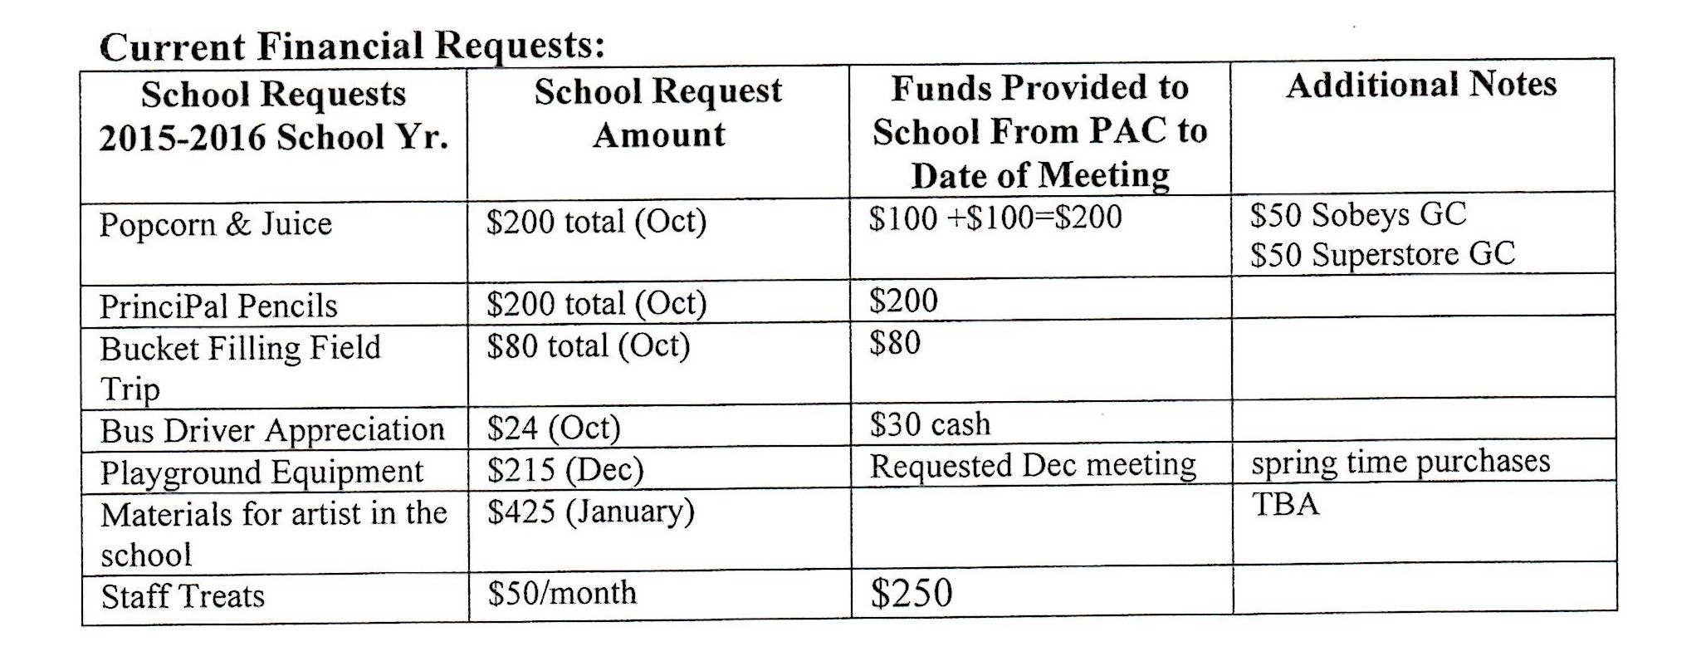
Financial Statements:
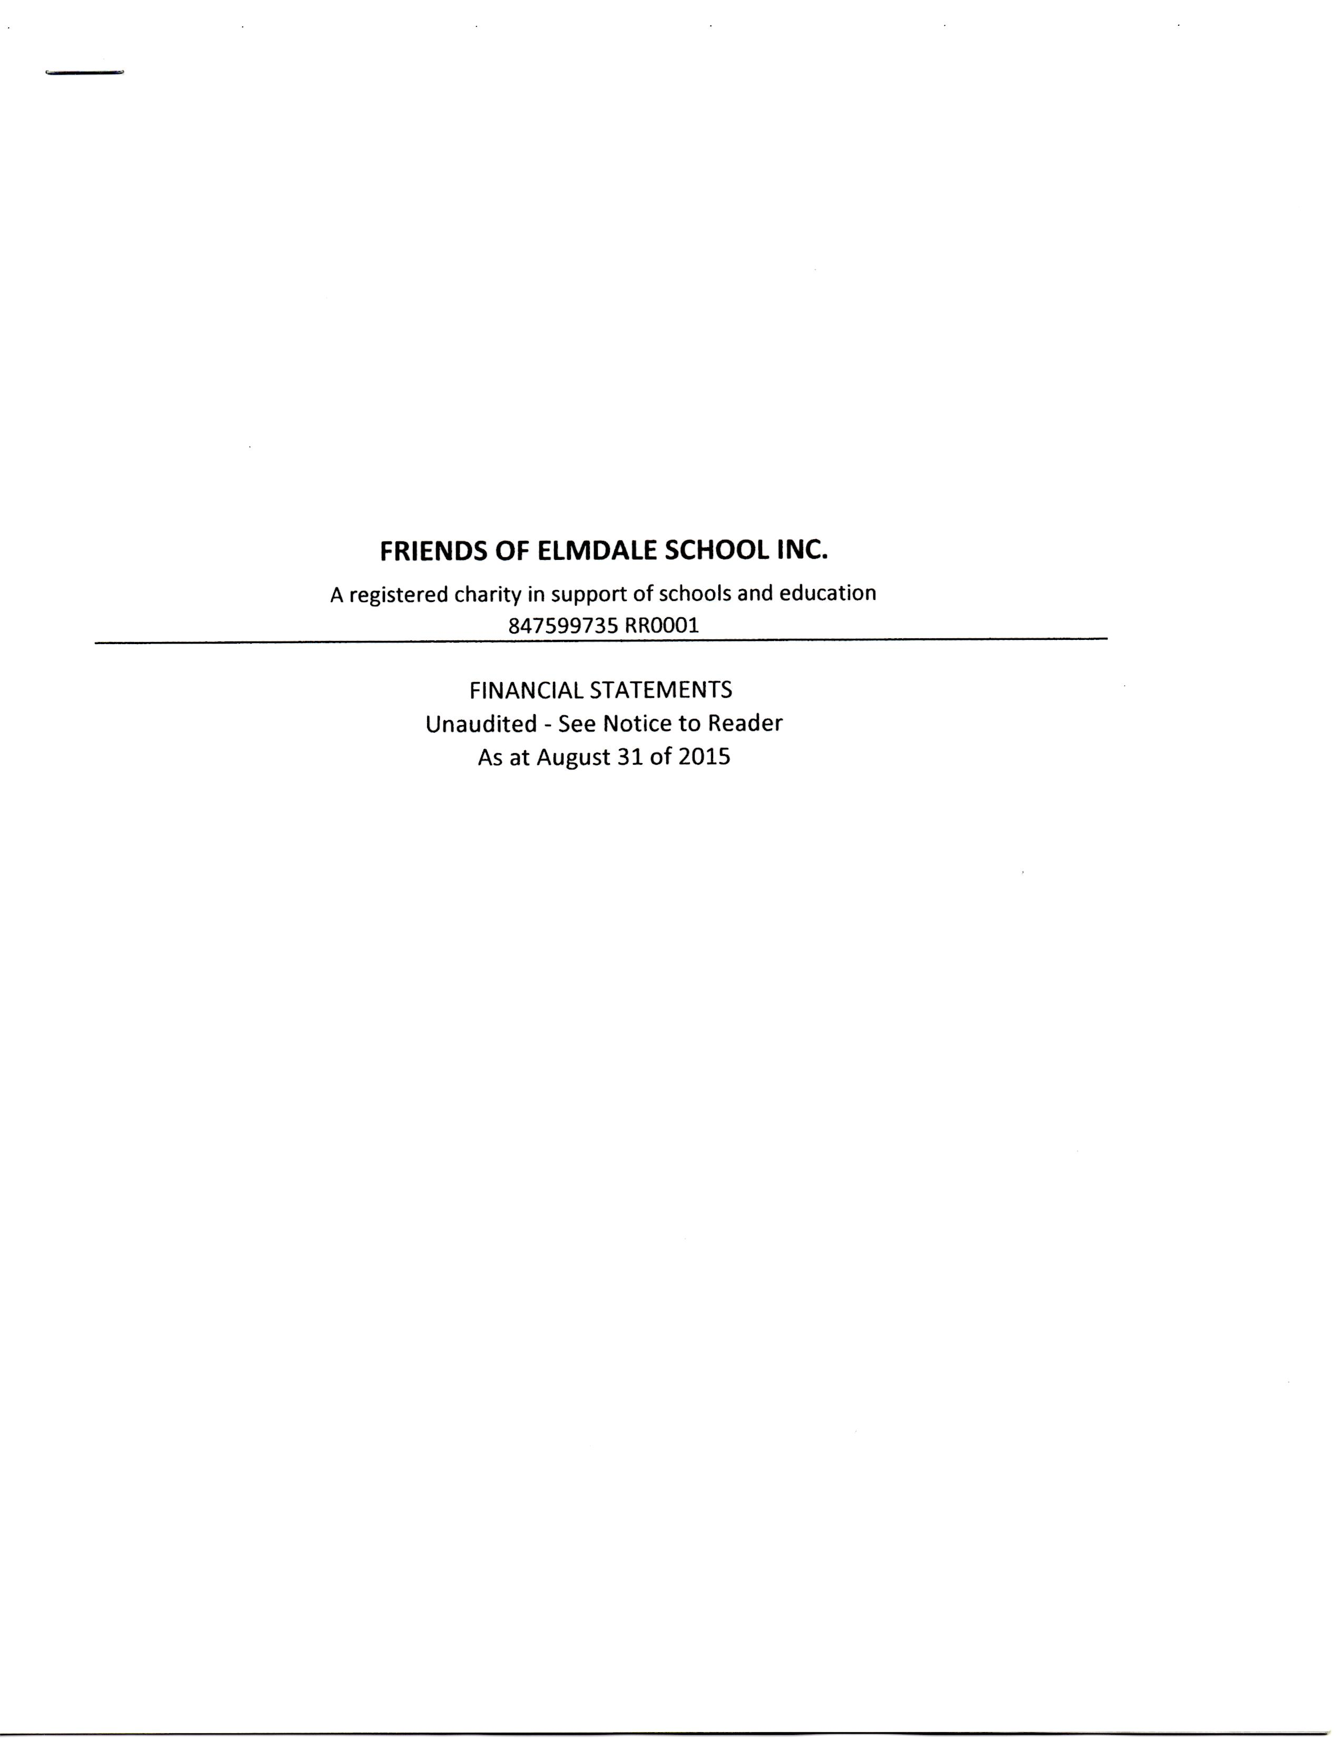
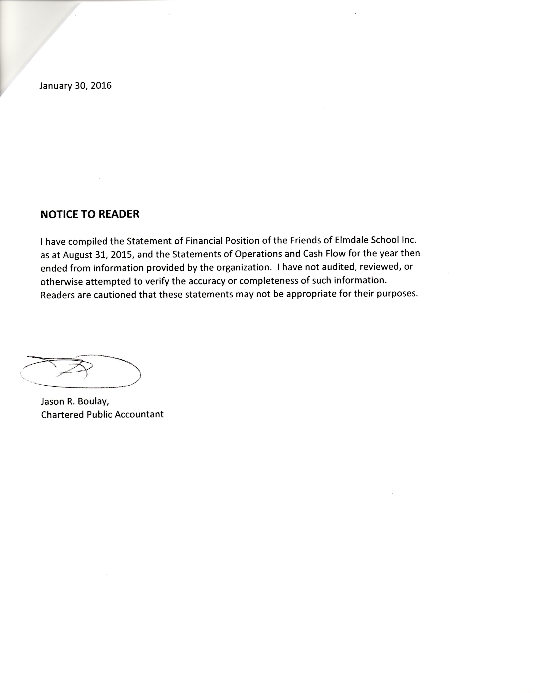

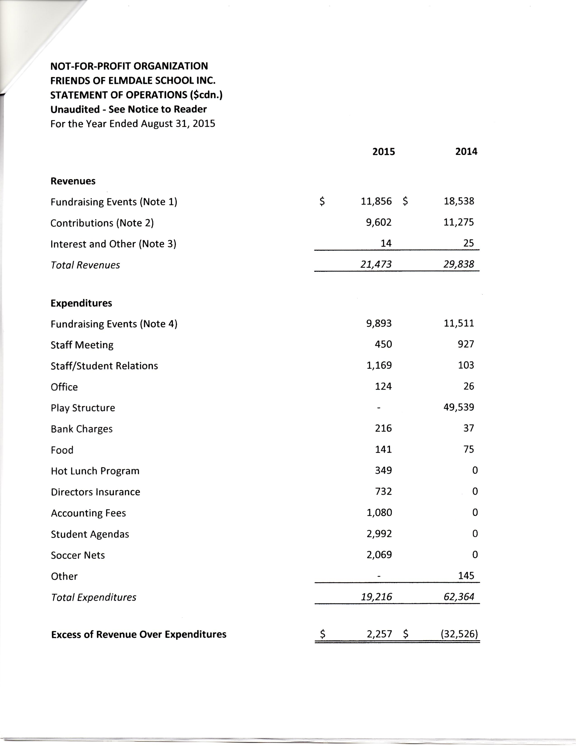
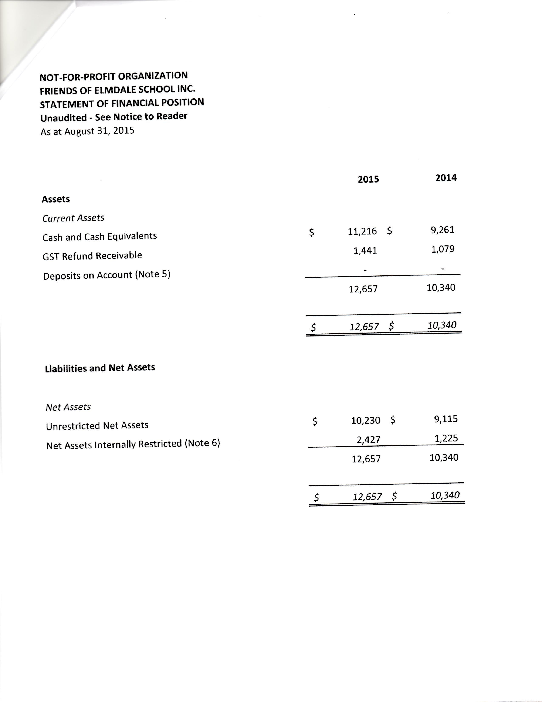
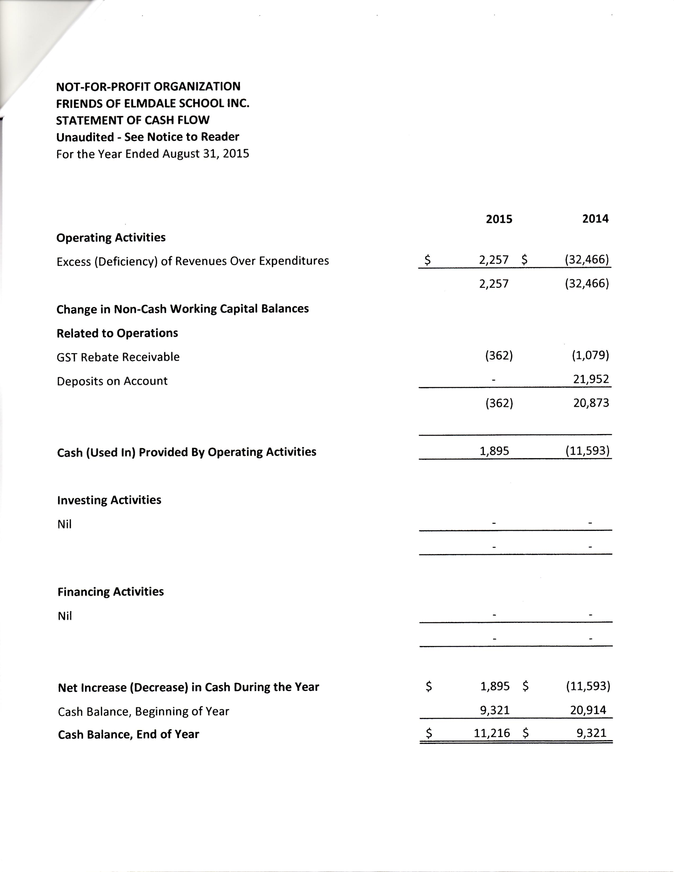
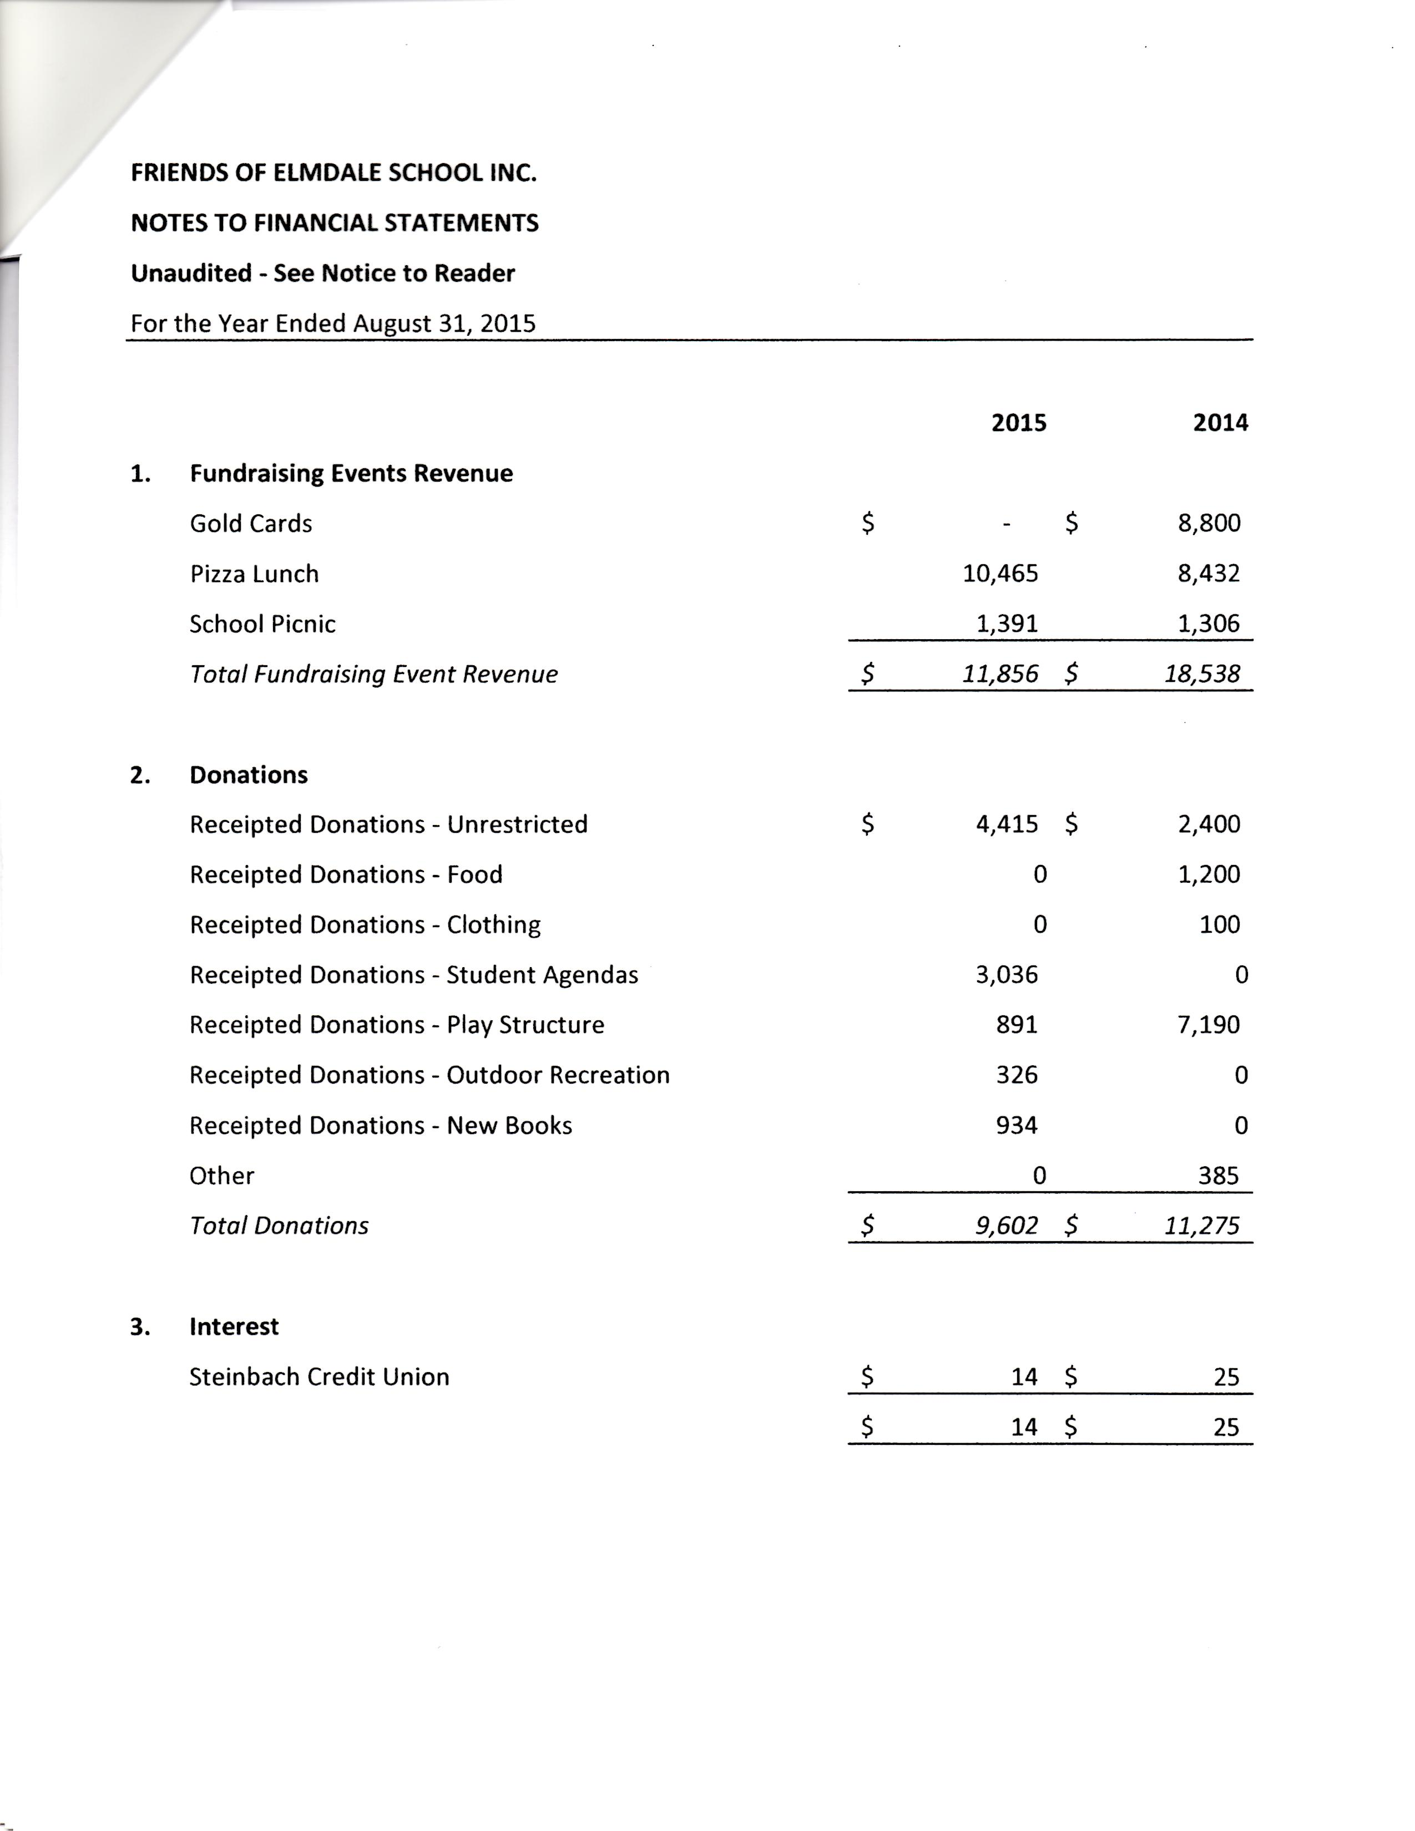
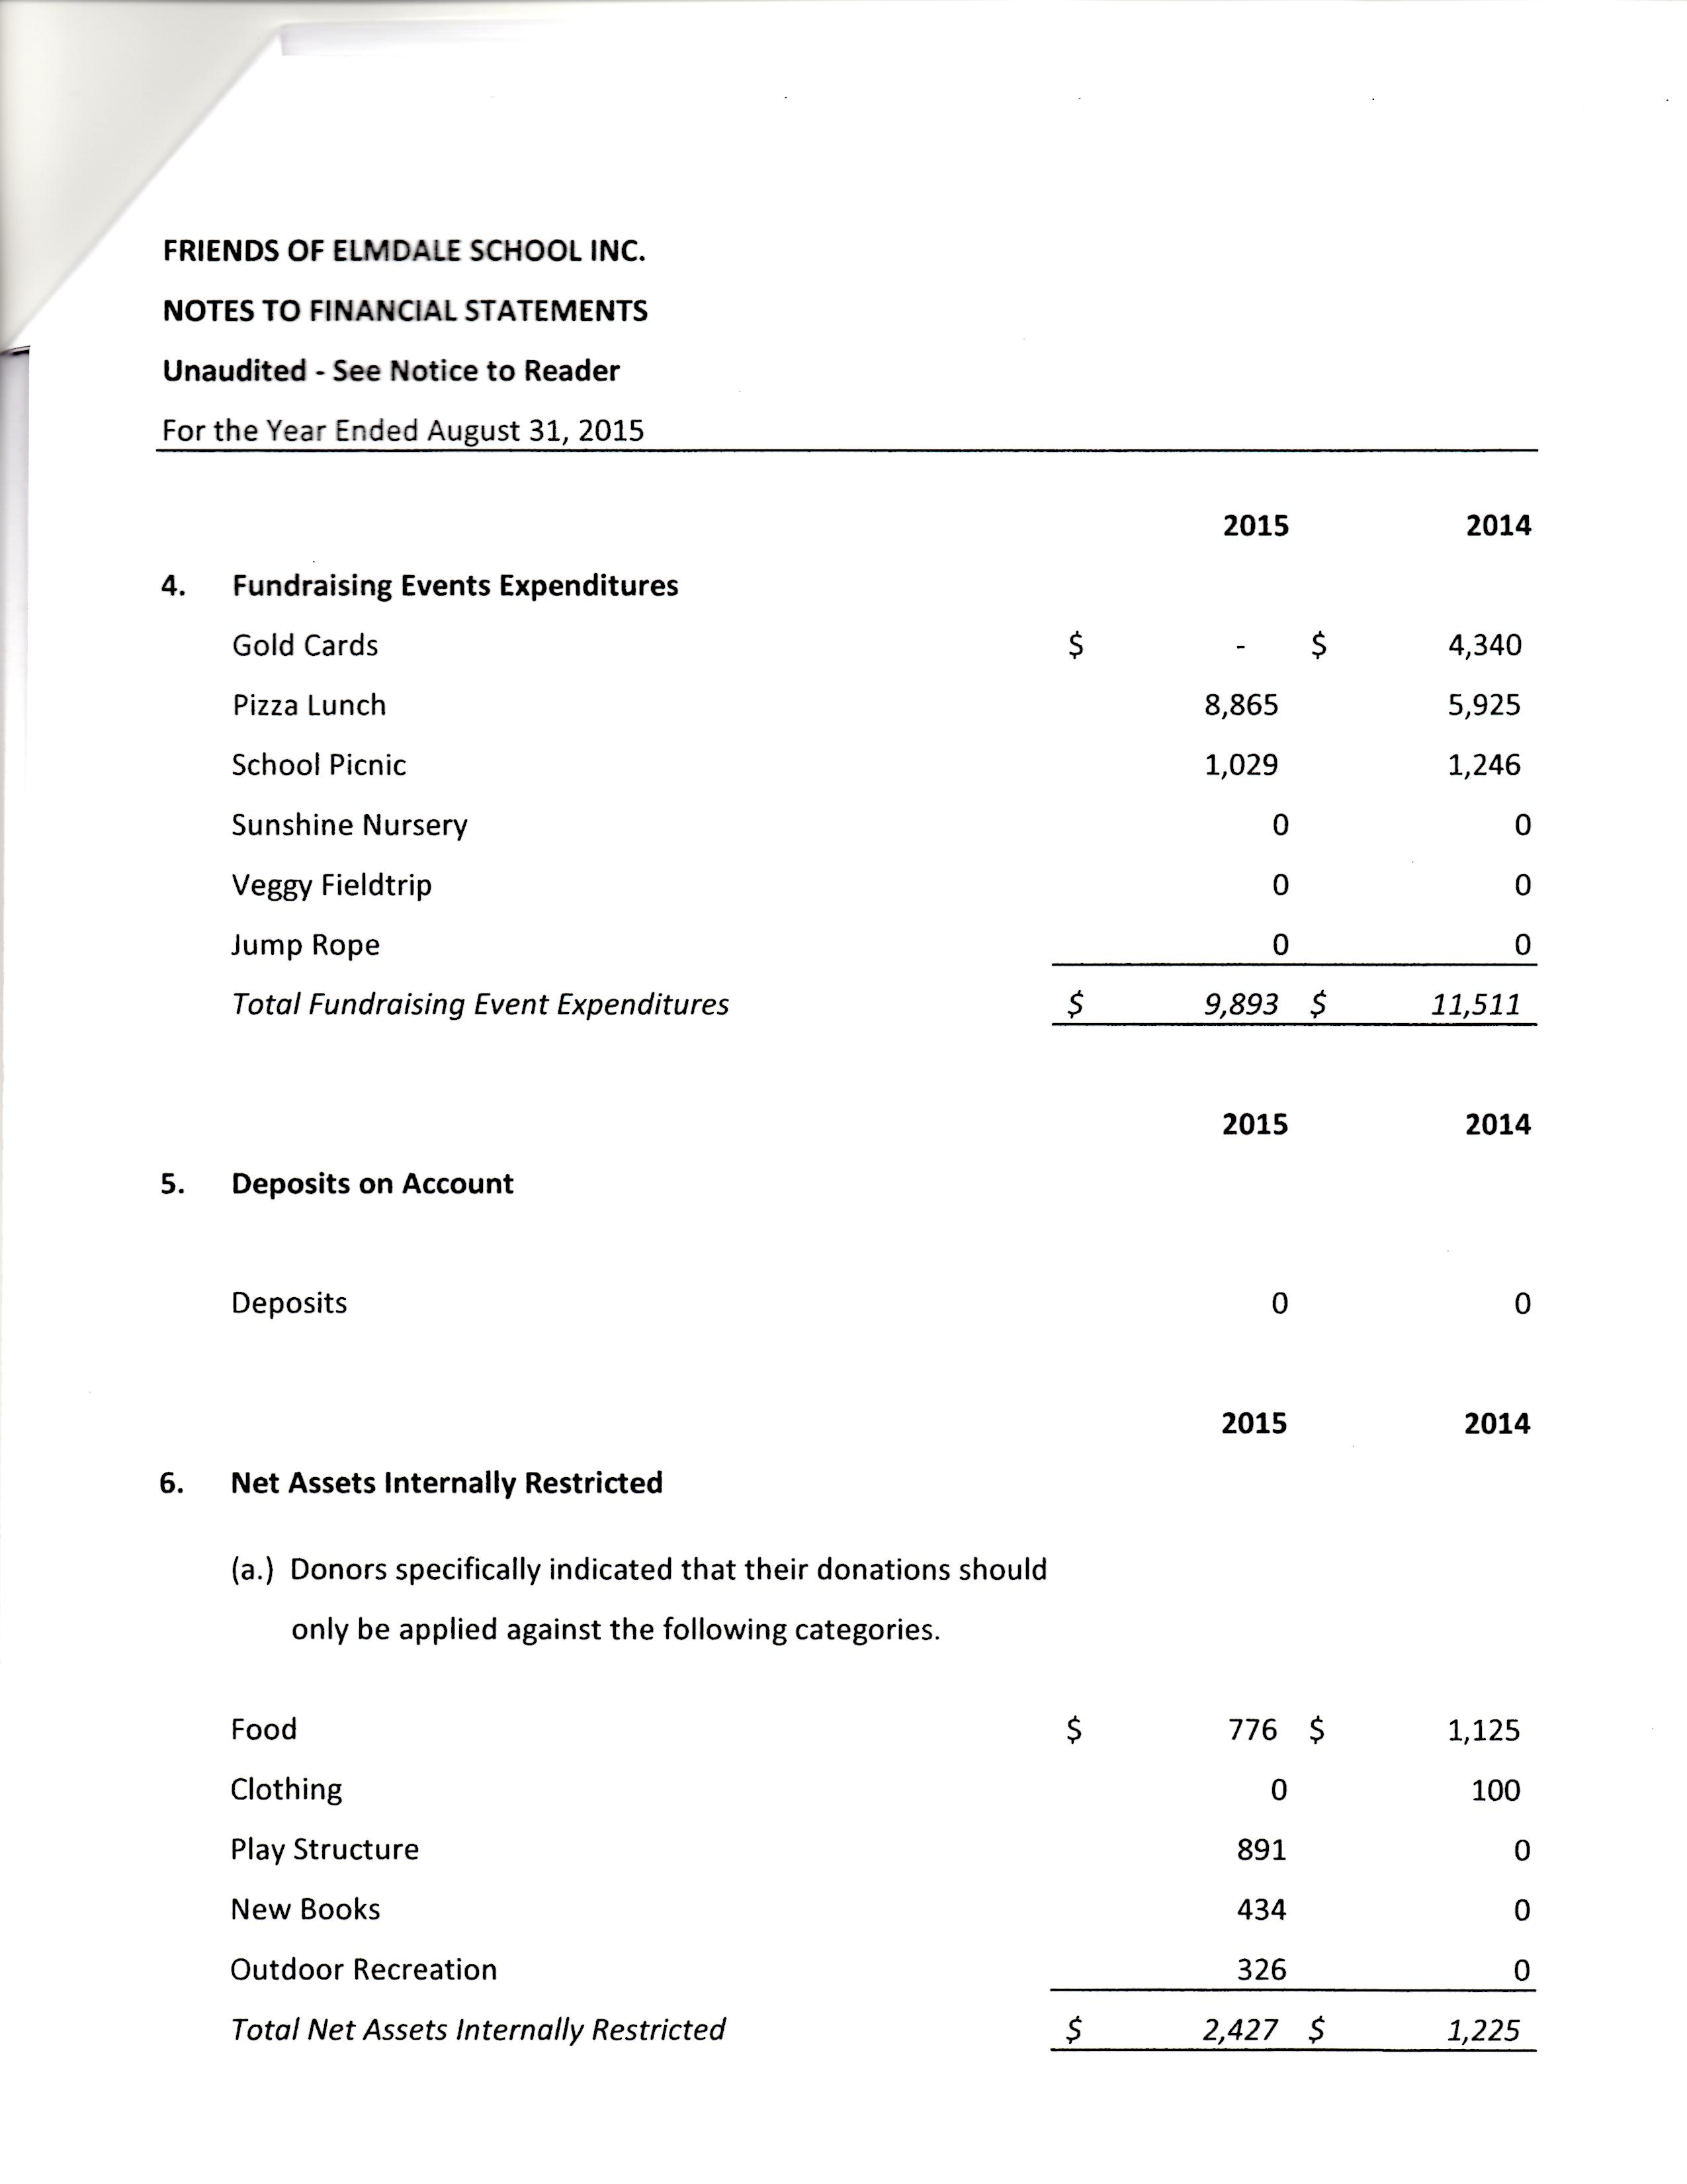
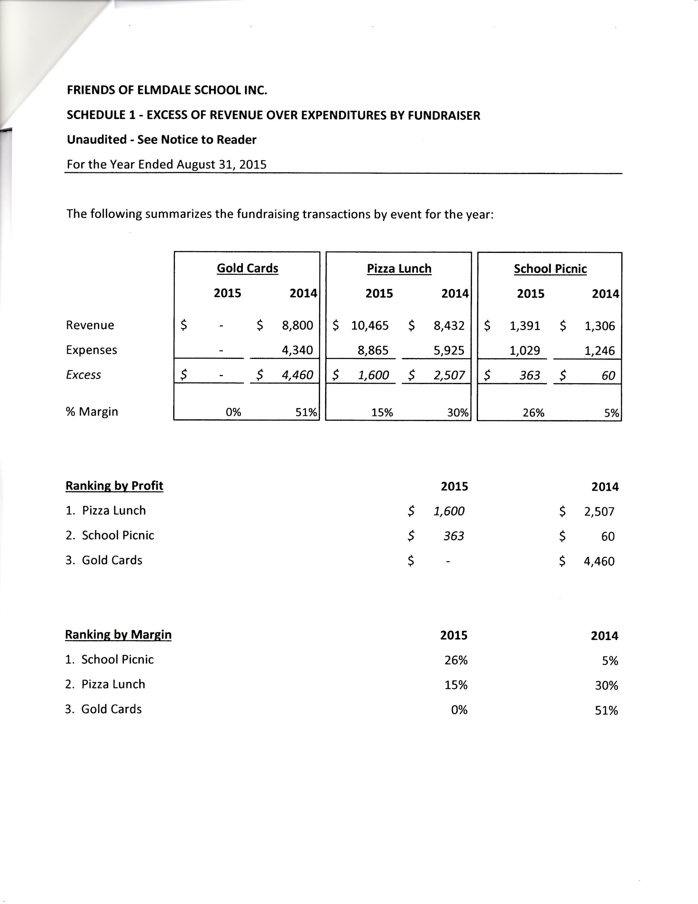
- Motion was passed to approve financial statements for 2015 year.

Friends of Elmdale School:
- Papers for dissolution of Friends of Elmdale School Inc. were signed by Sacha and given to the lawyer.
- Legal and accounting fees need to be wrapped up.

Phase 2 of Play Structure:
- 3 options with proposals were given to the PAC by PlayQuest.
- The PAC liked options 2 and 3 best along with a stand alone piece "Comet II"
- 3D drawings will be brought to the school and placed in a visible location to allow the students to see these options and vote on which one they like the best.
- A tentative time frame has been set for a Fall 2017 installation, providing all funds are in place.
- The PAC decided to go with PlayQuest Recreation as the supplier.

Fundraising:
- A Sunshine Nursery/Chinos Bistro fundraiser will be taking place from Mar. 7-18/16.
- Gift cards will be sold by students to raise funds for Phase 2 of the play structure.
- Delivery date of gift cards will be first week of April. (After Spring Break)

PAC Positions:
- Chair – Sacha Barkman asked to resign from this position a.s.a.p., so Laurena O' Connor has stepped in effective Feb. 18/16 as the new PAC Chair.
- Vice Chair – Since Laurena has stepped into the role of Chair, her position of Vice Chair became open, so Tess Doerksen has now stepped in to fill the role of Vice Chair.
- Secretary – Melissa Friesen will be leaving Elmdale School as of June 2016. The position of PAC Secretary urgently needs to be filled.
- Volunteer Coordinator and Pizza Lunch – Janet Mehling will resume these roles.
- Fundraising Coordinator – The PAC decided that fundraising would be a team effort. No one person is assigned to this role.

Newsletter Item:
The Elmdale Parent Advisory Council is a dedicated group of parents and guardians who meet once per month to discuss:
- Fundraising
- Upcoming events
- Improvements to school and classrooms
- Learning
- Finances.
The students of Elmdale School need strong advocates who can help to make the school a better learning experience.
Please consider joining the PAC for our next meeting on Tues. Mar. 8/16.

